CS 340 Client/Server Development
Module Seven – Project Two ReadMe
Rea Pridgett
Project Overview
For this project, I developed an interactive dashboard for Grazioso Salvare, an organization that trains rescue dogs. The dashboard helps the organization search animal shelter records and identify dogs that meet specific rescue training requirements.
The dashboard connects to a MongoDB database and allows users to filter animal records based on rescue categories. It also displays the results in an interactive table, pie chart, and map.
Tools and Technologies
I used Python to develop the dashboard and connect its components.
MongoDB stores the animal shelter records, while PyMongo allows Python to communicate with the database. I reused the CRUD Python module from Project One to retrieve animal records.
I used Dash and JupyterDash to create the interactive dashboard. Pandas organizes the database records into a DataFrame, Plotly Express generates the pie chart, and Dash Leaflet displays animal locations on a map.
These tools work together to retrieve, filter, organize, and visualize the animal shelter data.
Dashboard Features
The dashboard includes four filtering options.
Water Rescue displays qualifying female dogs between 26 and 156 weeks old.
Mountain or Wilderness Rescue displays qualifying male dogs between 26 and 156 weeks old.
Disaster or Individual Tracking displays qualifying male dogs between 20 and 300 weeks old.
All Animals (Reset) removes the rescue filters and displays the complete dataset.
Each rescue category also filters animals by the breeds specified in the project requirements.
The interactive table allows users to sort records, filter columns, navigate between pages, and select individual animals.
The pie chart shows the distribution of animal breeds based on the current results. When a rescue category is selected, the chart updates automatically.
The map displays the geographic location of the selected animal. Selecting another animal in the table updates the location marker.
Instructions for Reproducing the Dashboard
- Open JupyterLab in the Codio environment.
- Place ProjectTwoDashboard.ipynb, CRUD_Python_Module.py, and Grazioso Salvare Logo.png in the same working directory.
- Make sure MongoDB is running and the animal shelter dataset has been imported into the aac database.
- Verify that the database credentials in the notebook match the configured MongoDB account.
- Open ProjectTwoDashboard.ipynb.
- Run the notebook to launch the dashboard.
- Select the different rescue categories to filter the animal records.
- Select an animal in the table to display its location on the map.
The application requires the Python libraries used in the notebook, including Dash, JupyterDash, PyMongo, pandas, Plotly, and Dash Leaflet.
Challenges and Solutions
One challenge I encountered was getting the dashboard callbacks to work correctly. Initially, an error occurred when no table column was selected. I corrected this by updating the callback to handle an empty selection.
I also encountered an indentation error while modifying the map callback. After correcting the indentation, the dashboard ran successfully.
Another challenge was making sure the rescue filters updated the table and visualizations correctly. I tested each rescue category individually and confirmed that the displayed records changed based on the selected filter.
Testing and Results
I tested the dashboard using all four filtering options. Water Rescue, Mountain or Wilderness Rescue, and Disaster or Individual Tracking each returned filtered animal records based on the specified requirements.
I also tested the Reset option and confirmed that it restored the complete dataset.
The pie chart updated when the rescue filters changed. I also selected different animals in the table and confirmed that the map marker moved to reflect the selected animal's location.
The five screenshots included in this document demonstrate the initial dashboard, the three rescue filters, and the Reset functionality.
Conclusion
This project helped me understand how to connect a MongoDB database to an interactive Python dashboard. I reused the CRUD module from Project One and built on the dashboard developed during Module Six.
The completed application allows Grazioso Salvare to review animal shelter records, identify potential rescue dogs, and visualize the results in one place.
- Initial Dashboard (Unfiltered)
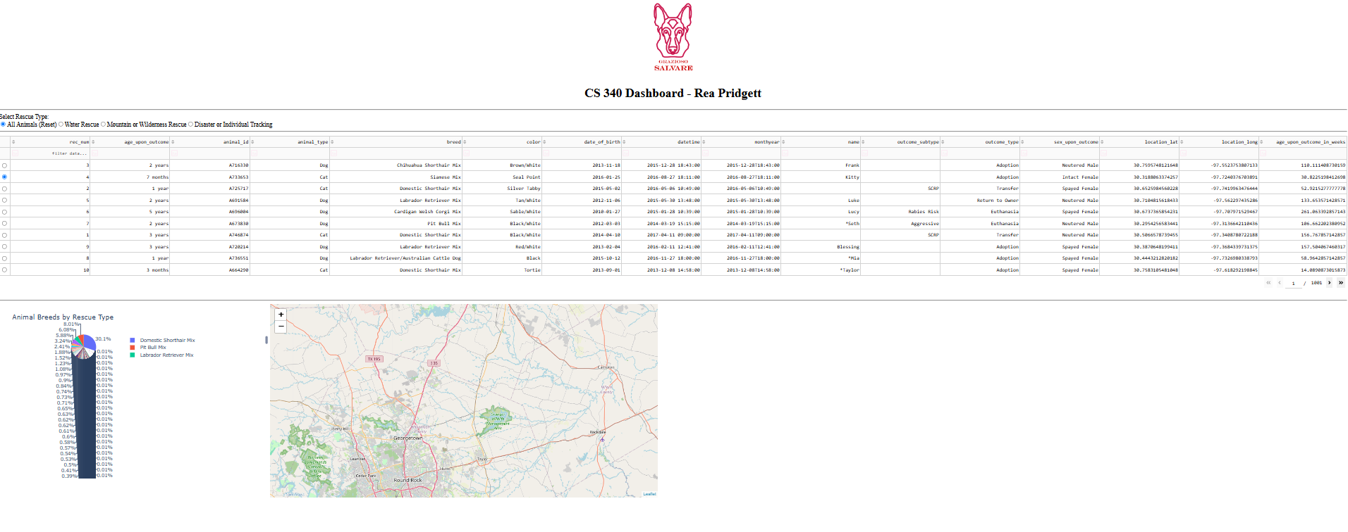
2. Water Rescue
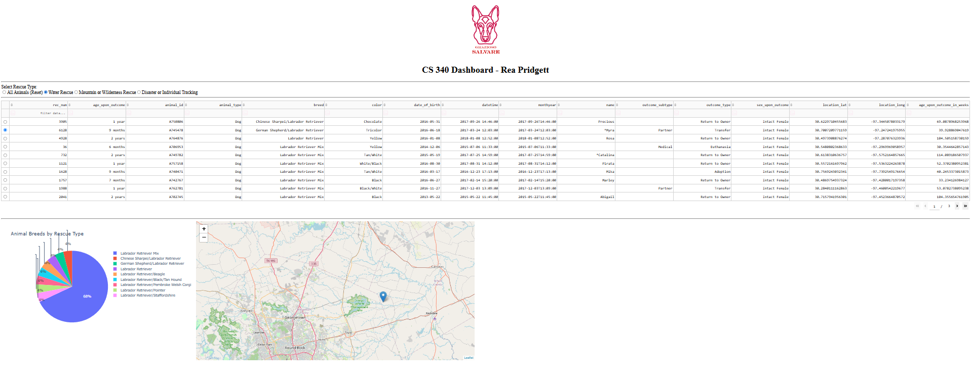

- Mountain or Wilderness Rescue
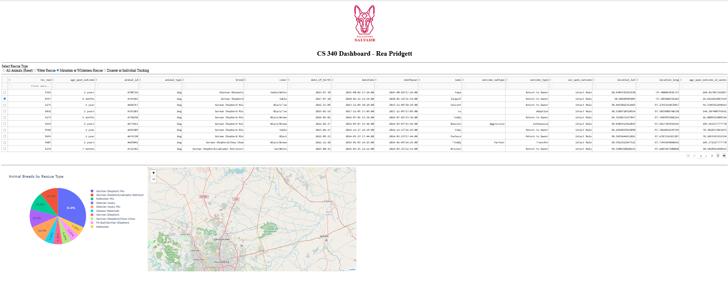

- Disaster or Individual Tracking
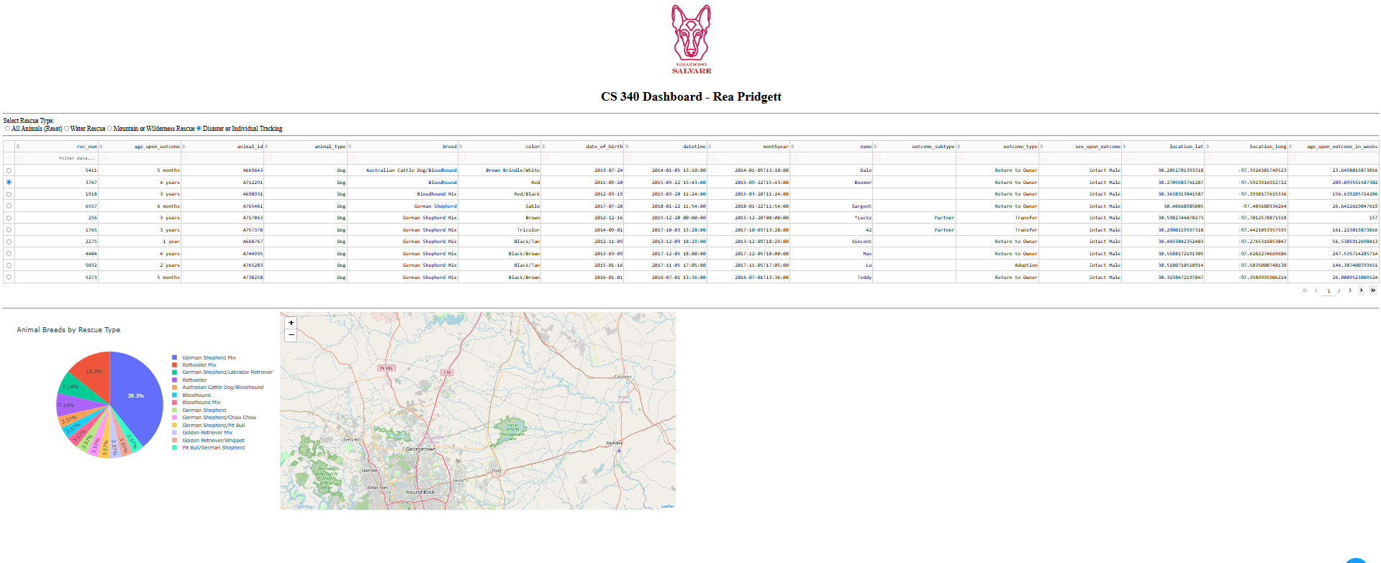
- Reset (All Animals)
